**SQL Project:**

**AtliQ Hardwares.**

**Problem Statement:**

AtliQ Hardware, a prominent company renowned for its global presence, specializes in manufacturing PCs, printers, mice, and computers The increased size of Excel files has resulted in performance issues, causing delays and inefficiencies. AtliQ Hardware has initiated a project to address this challenge, forming a team of data analysts. Leveraging MySQL as their database management system, the team aims to extract valuable insights from the data. These insights will empower the company to improve decision-making and streamline operations, leading to enhanced overall performance.

**Project Overview:**

This project aims to analyze and derive valuable insights from the provided database, encompassing sales, products, customers, and regions data for Atliq Hardware. The objective is to address specific inquiries regarding sales reports, market analysis, customer behavior, and supply chain forecasting.

**Tables**

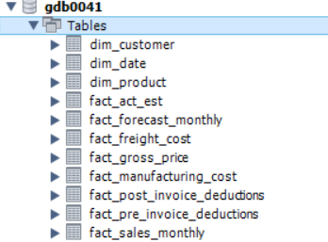

**Views**

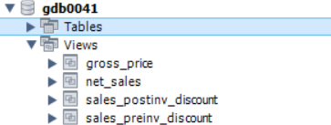

**Stored Procedures**

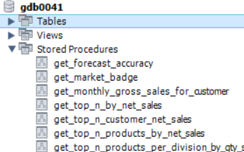

**Functions**

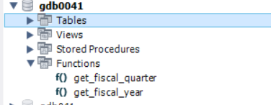

2021 Sales Report for Croma Categorized by Product.

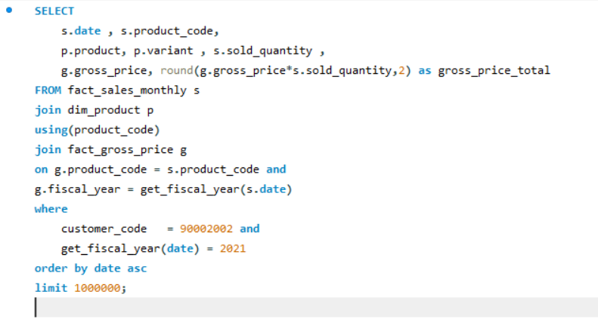

Output:

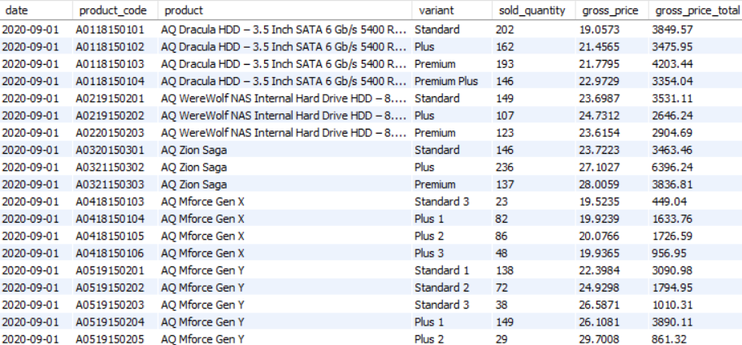

Yearly Sales Report for Croma

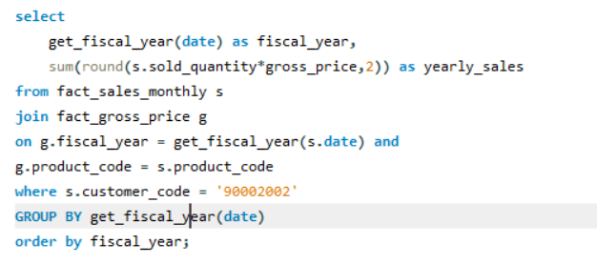

Output:

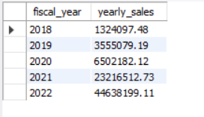

Key Markets and Prime Customers in the financial year -2021

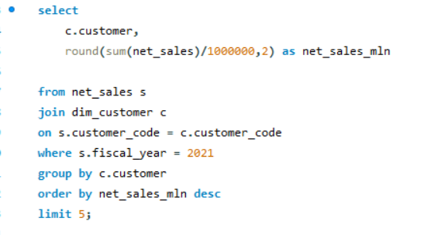

Output:

(Customers)

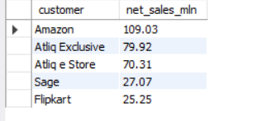

(Markets)

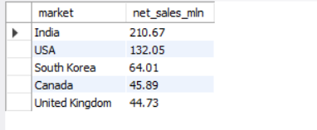

% of net sales contributed by customers in the market share

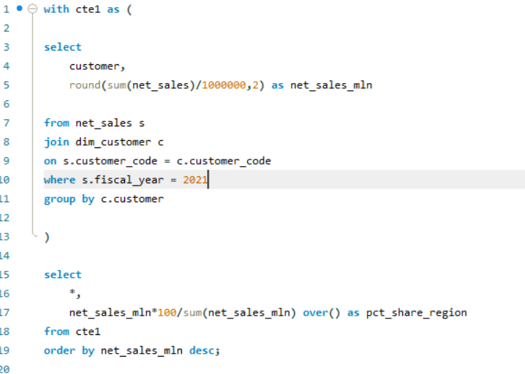

Output:

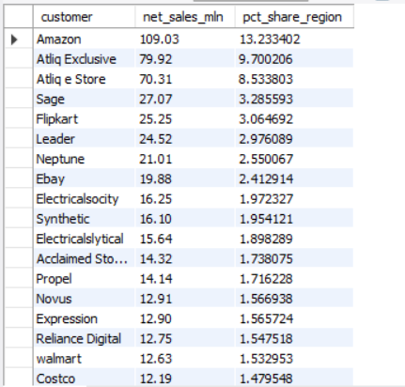

% of market share by region based on net sales

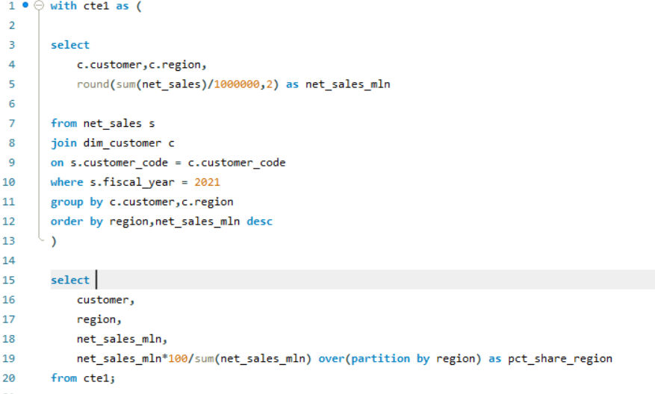

Output:

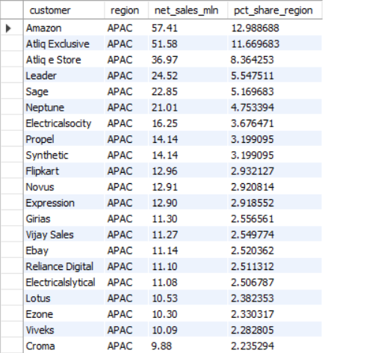

Highest Gross Sales in each Regiond top 2 markets

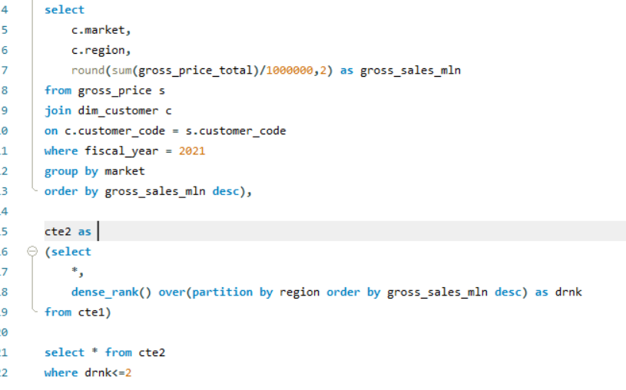

Output:

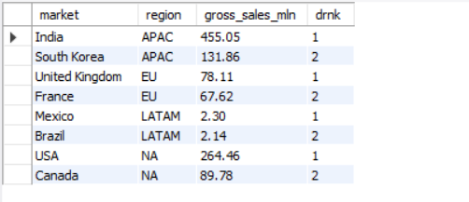

**Conclusion:**

* Net sales of Amazon is highest with 109.03M in fiscal year 2021 followed by AtliQExclusive with 79.92M
* Market in India generated maximum net sales with 210.67M in fiscal year 2021 followed by USA with 132.05M
* Amazon generated 13.23% of total net sales among all customers in fiscal year 2021
* In APAC region, Amazon contributed maximum net sales % of 12.99 % among rest customers in 2021.
* India secures the top spot in total gross sales within the APAC region.